**MODULE-1**

**EXPERIMENT -1**

**AIM:** Write an HTML code to display your CV on a web page.

**CODE:**

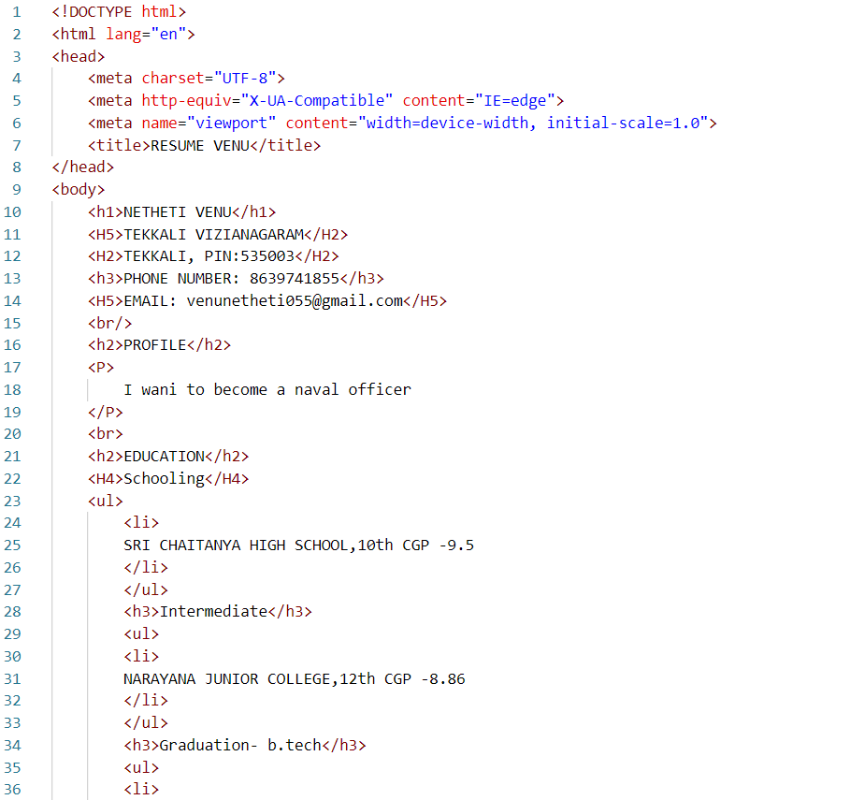

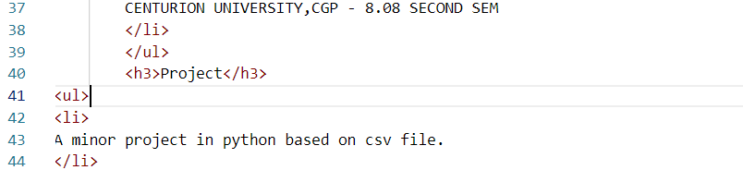

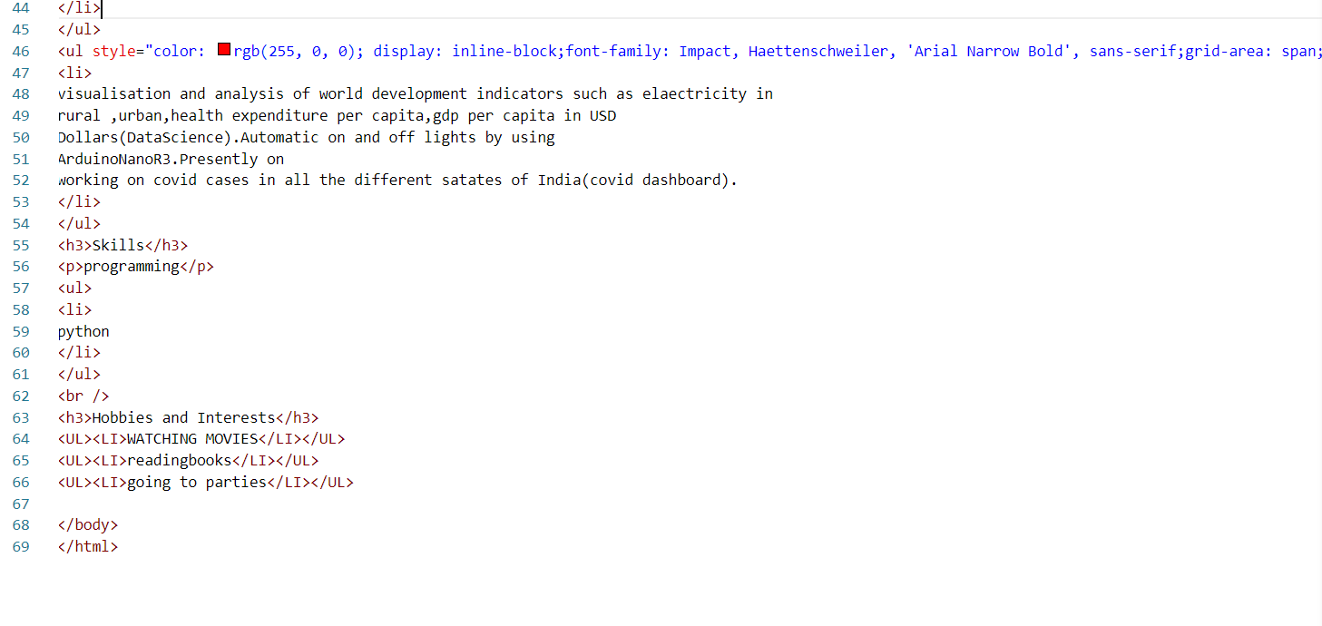**OUTPUT:**

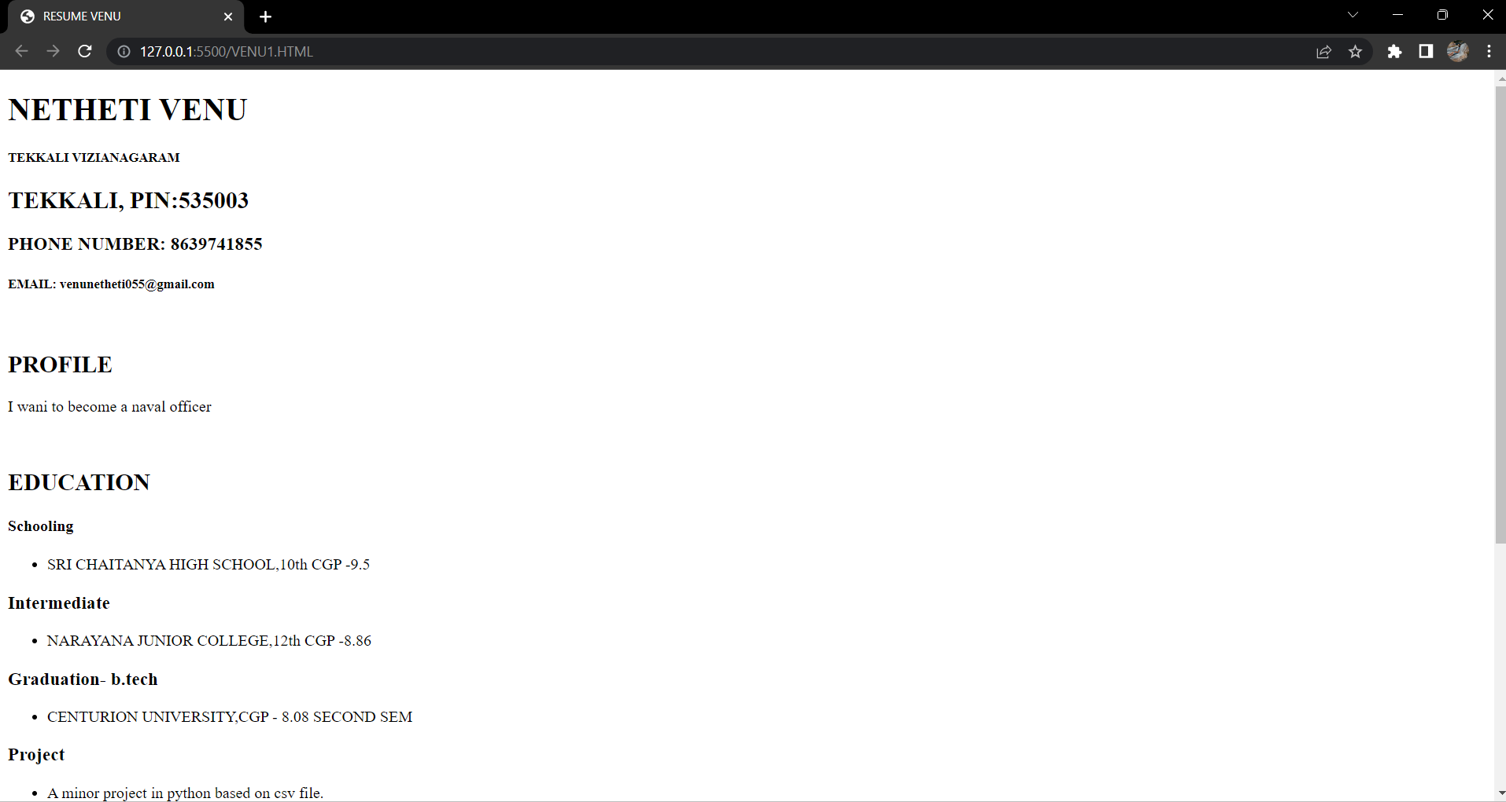

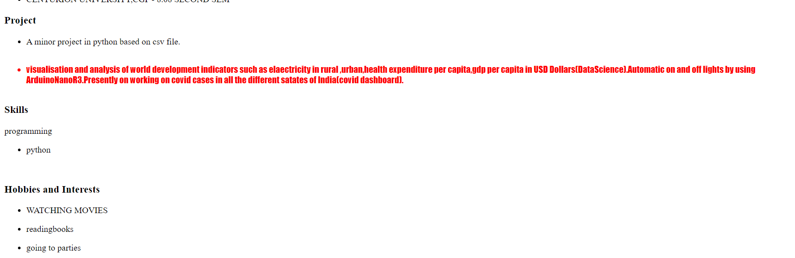

**EXPERIMENT -2**

**AIM:** code to create a Home page having three links: About Us, Our Services and Contact Us. Create separate web pages for the three links.

**CODE:**

<--HOMEPAGE-->

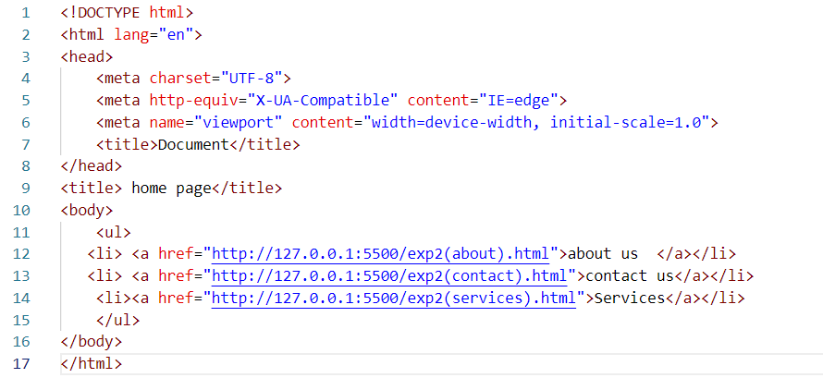

<-- ABOUT US -->

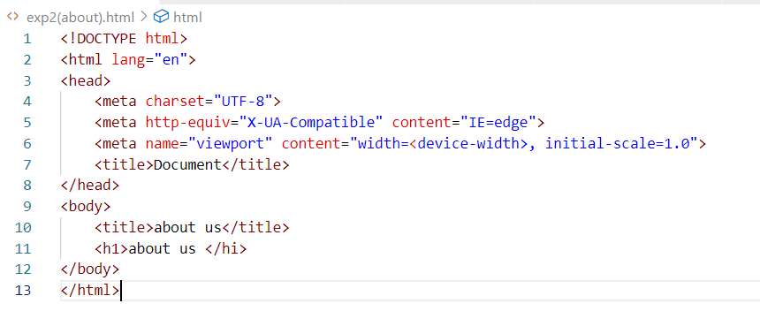

<-- CONTACT US -->

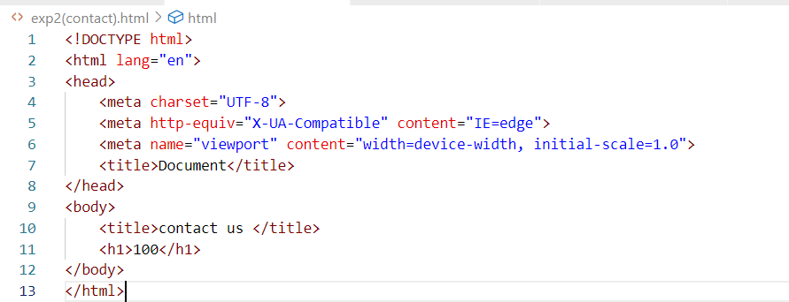

<-- SERVICES -->

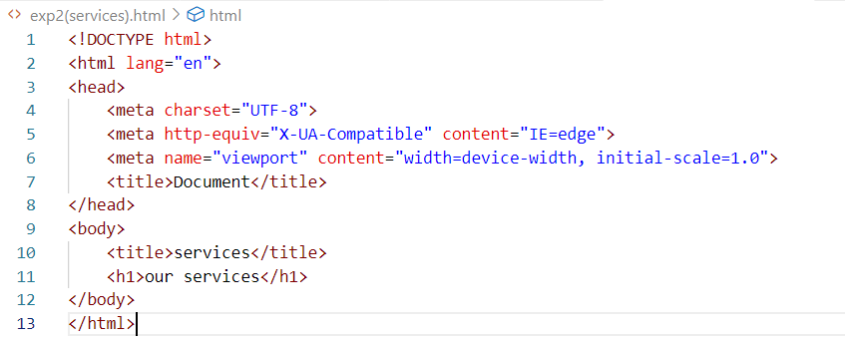

**OUTPUT:**

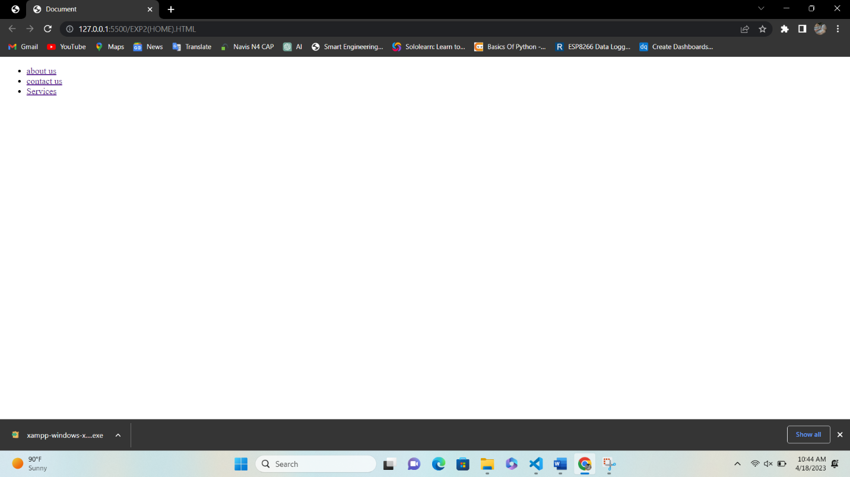

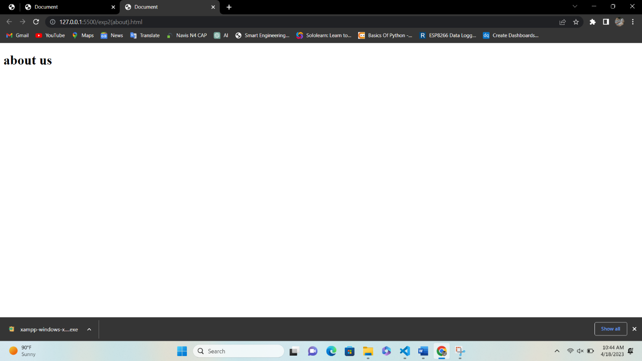

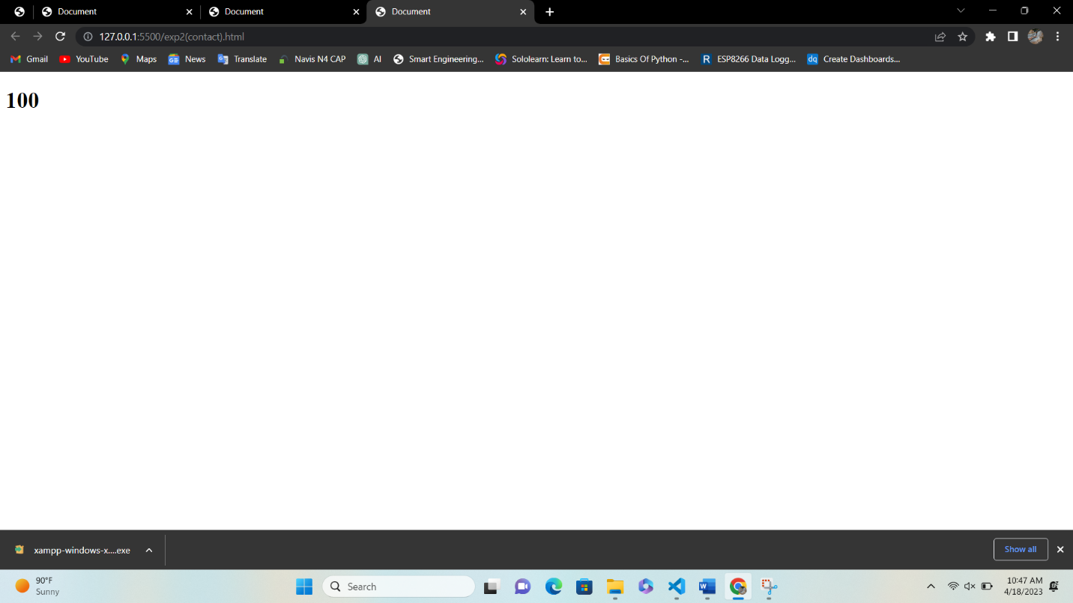

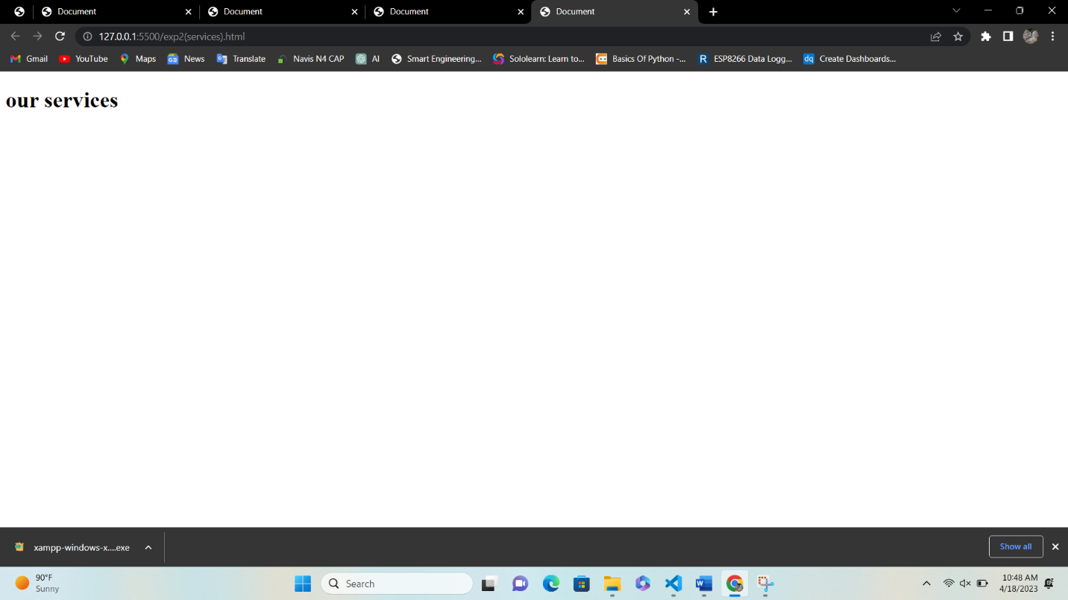

**EXPERIMENT-3**

**AIM:** Write an HTML code to create a Registration Form. On submitting the form, the user should be asked to login with thisnew credentials

**CODE:**

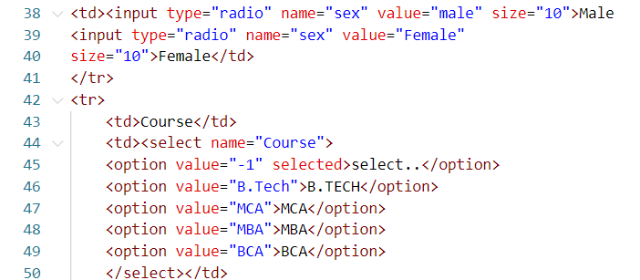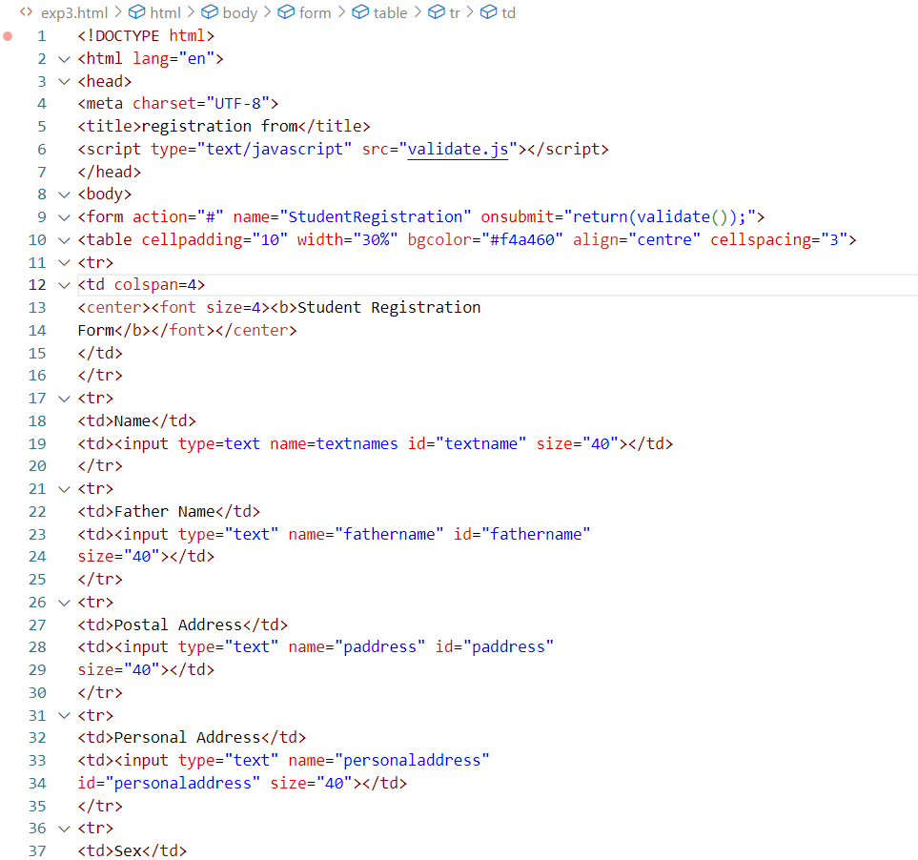

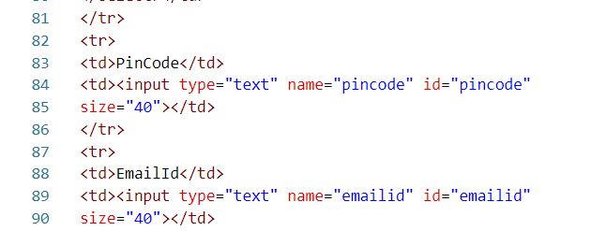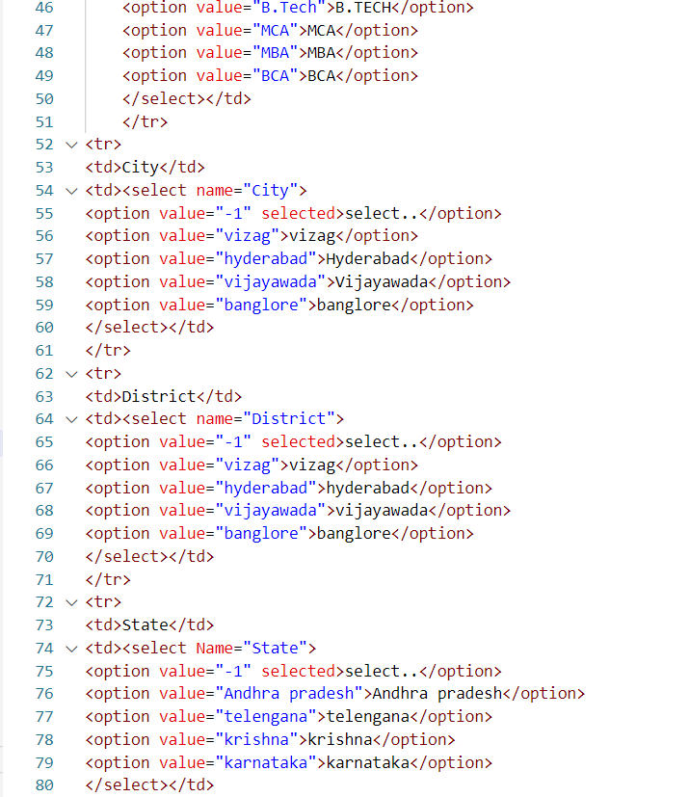

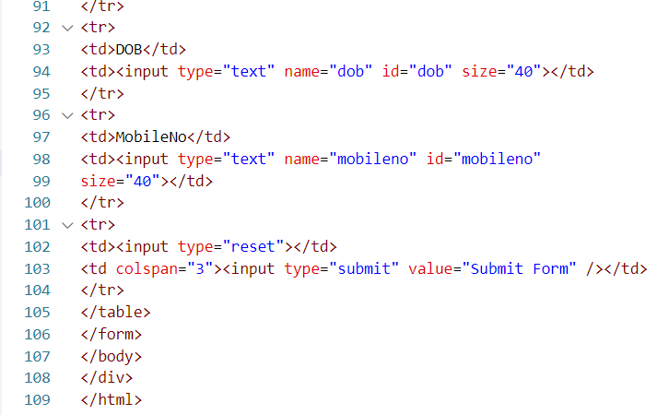

**OUTPUT:**

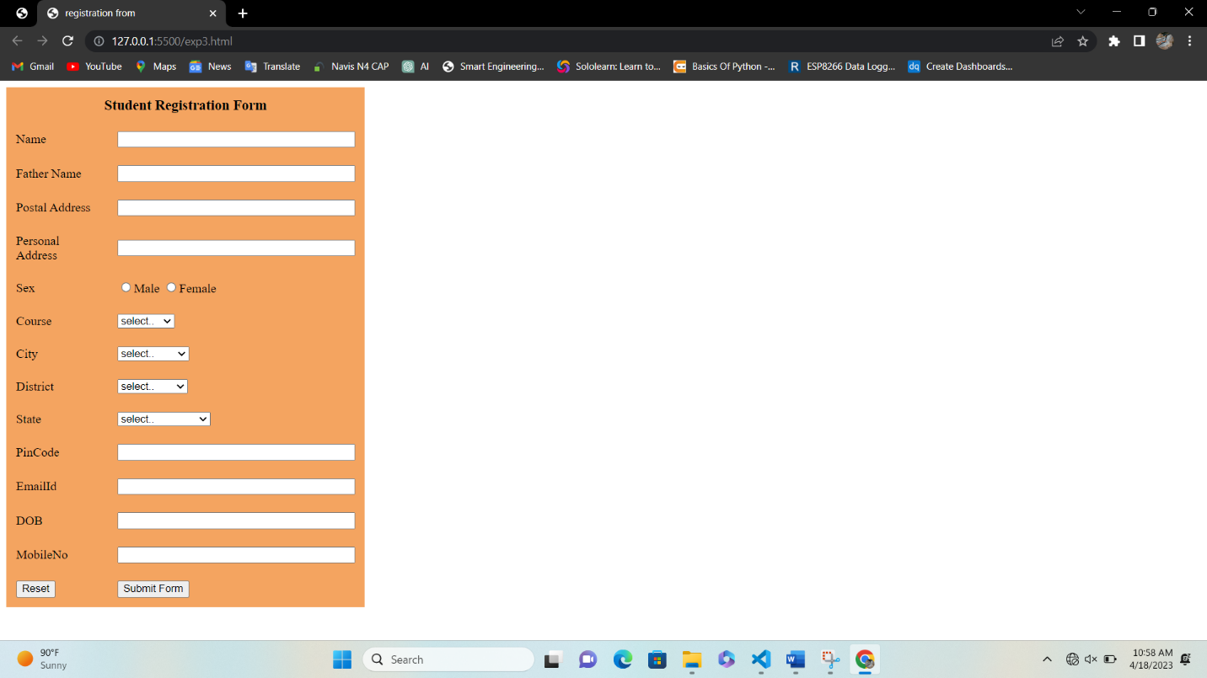

**EXPERIMENT-4**

**AIM:** Write an HTML code to create your Institute website, Department Website and Tutorial website for specific subject.

**CODE:**

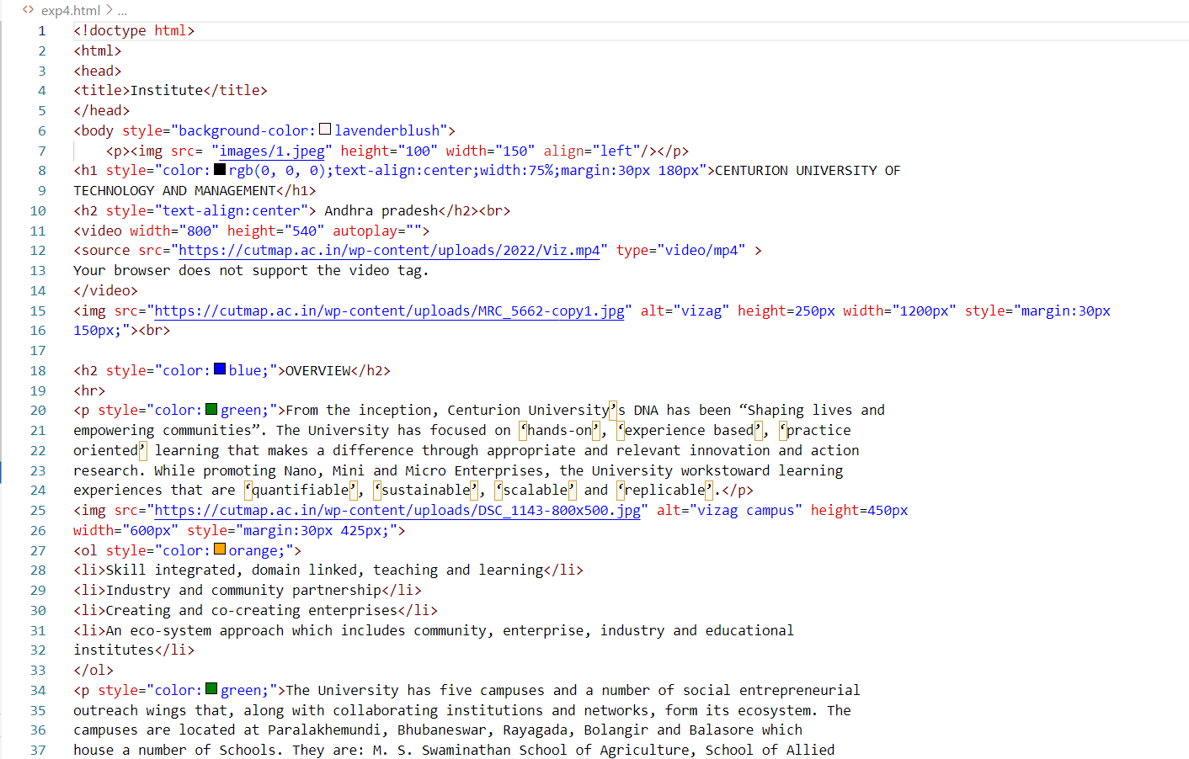

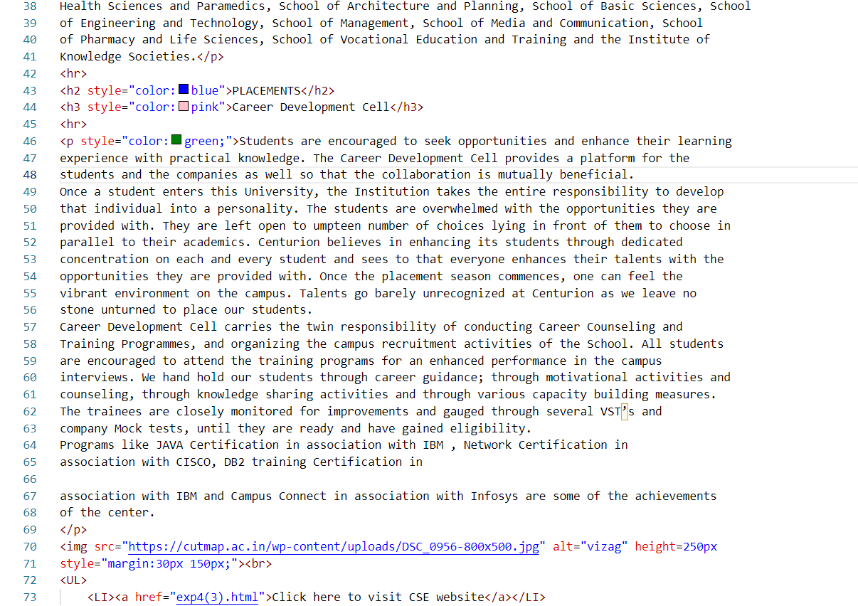

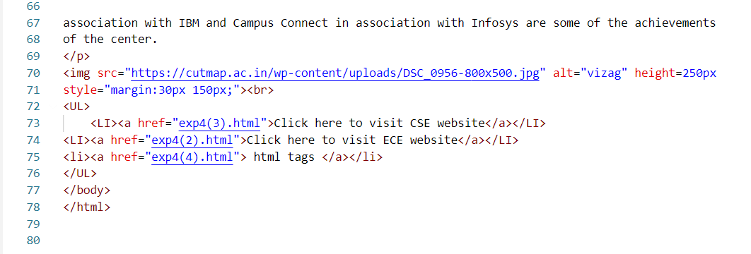

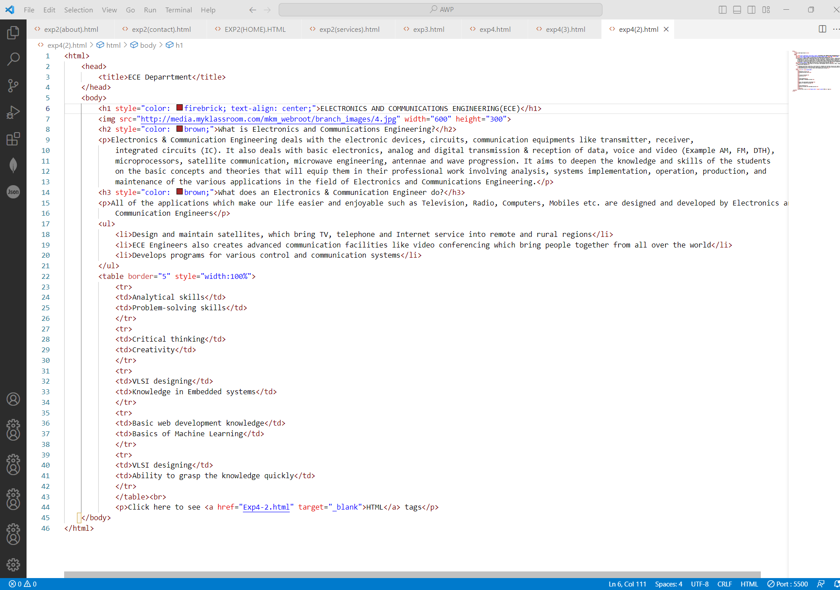4(2)

4(3)

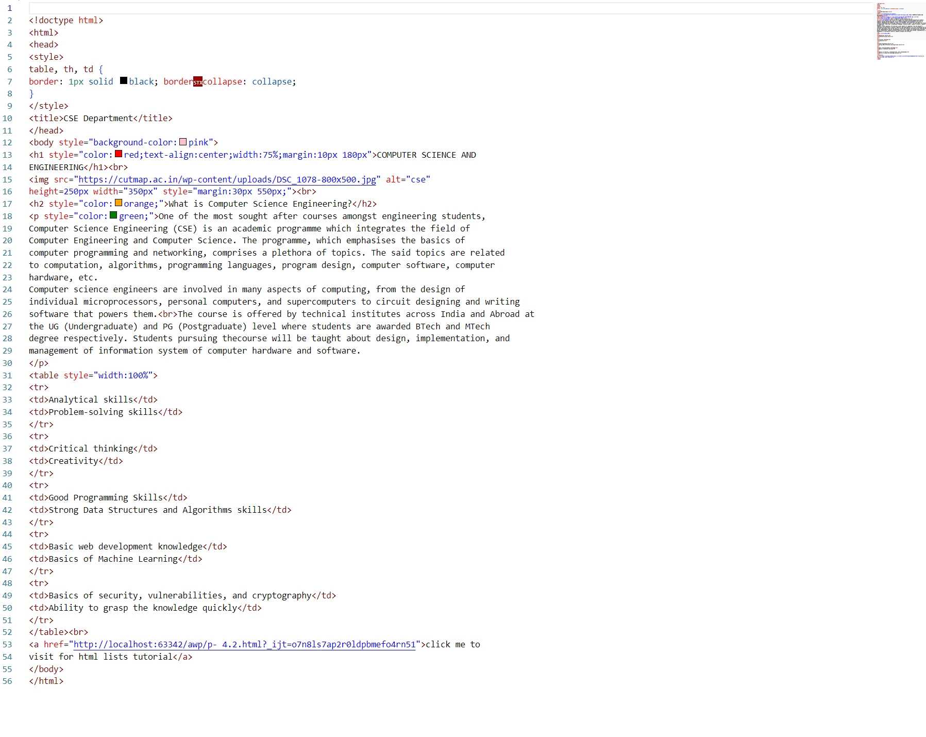

4(4)

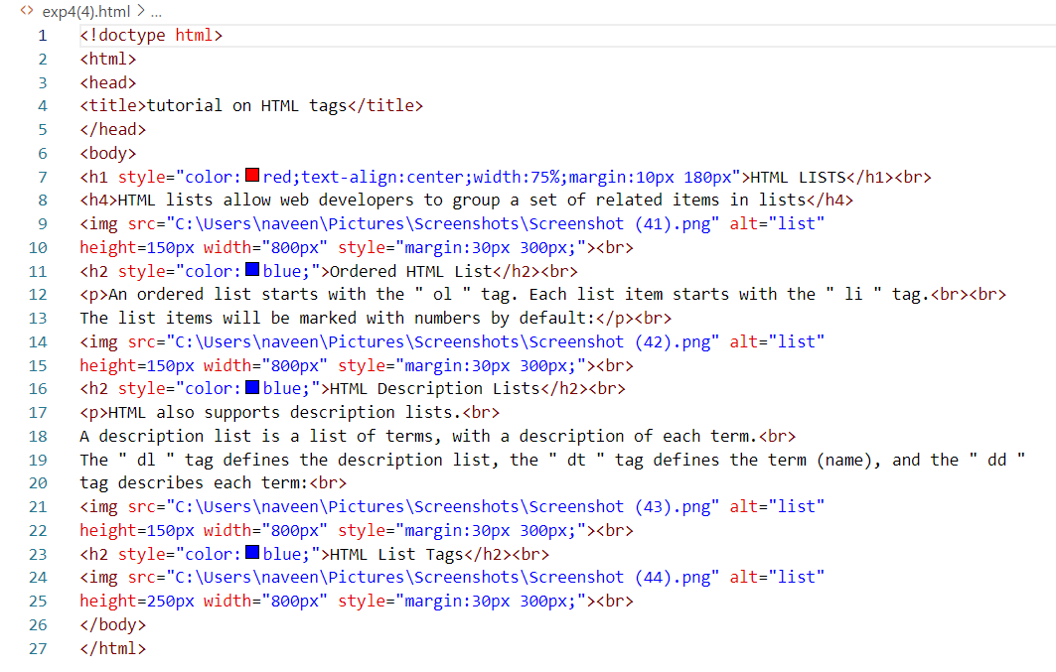

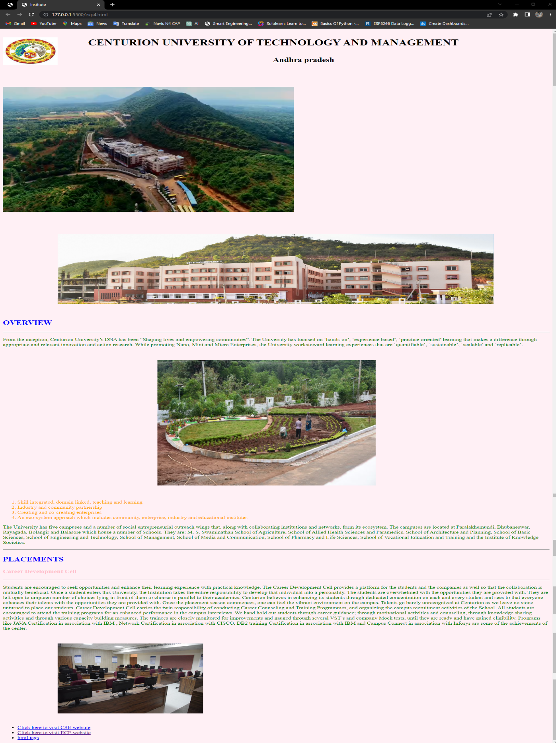**OUTPUT:**

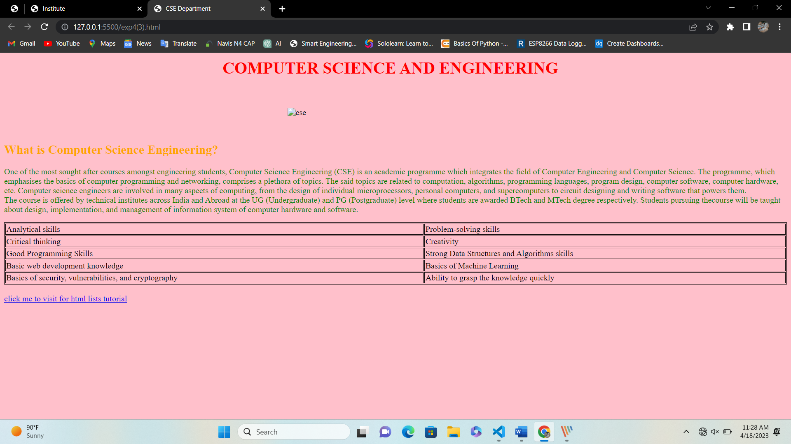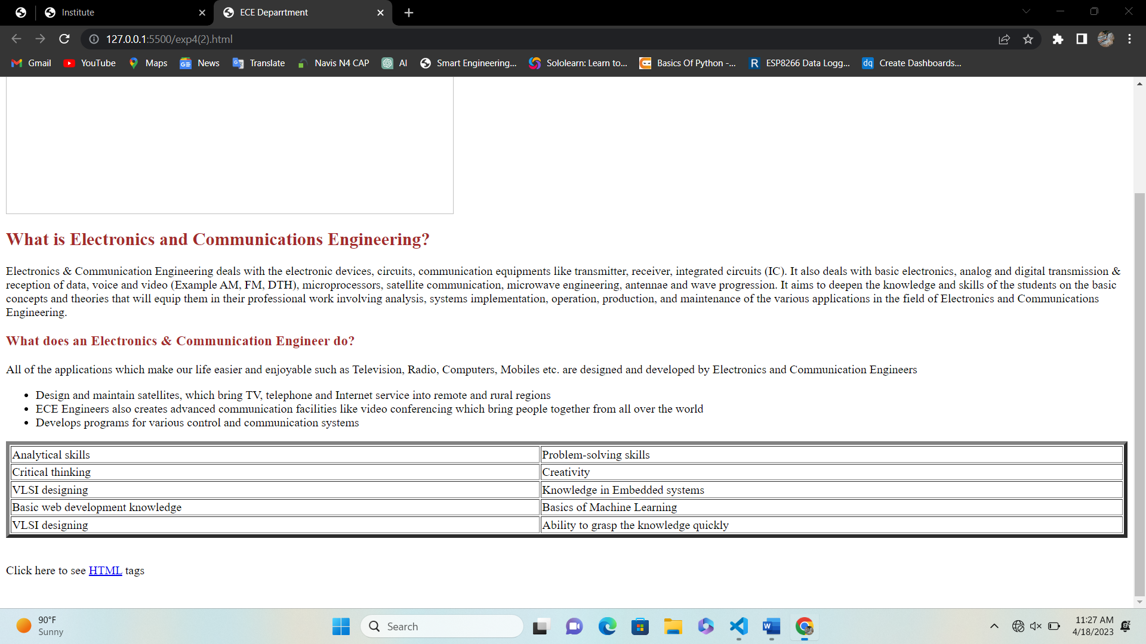

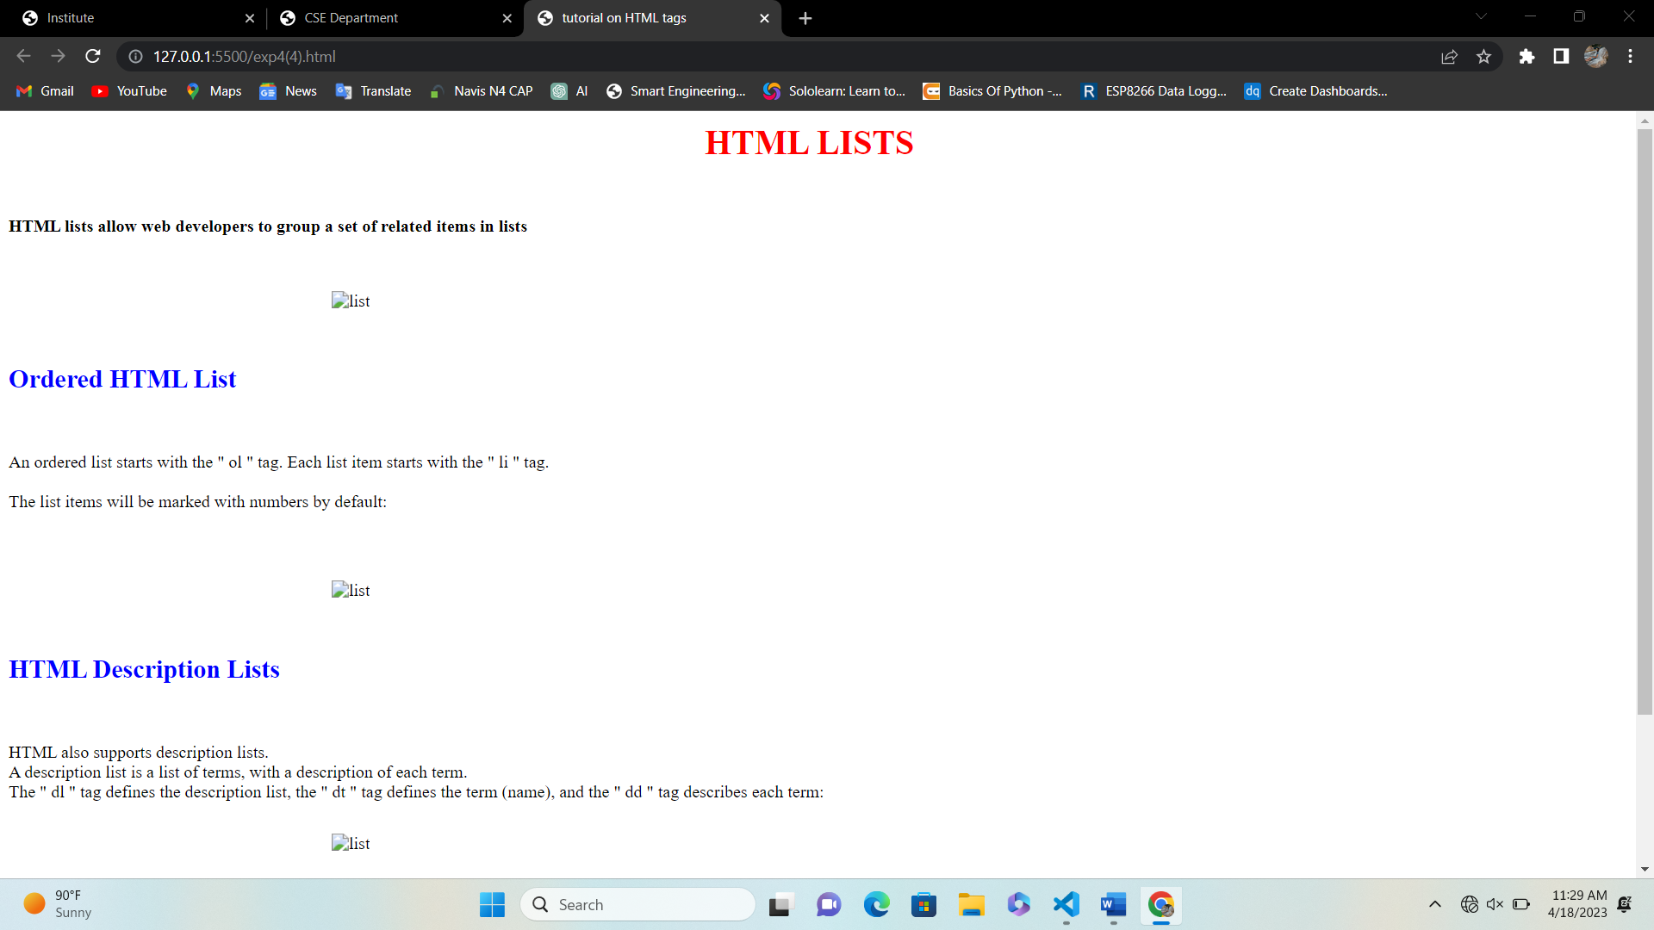

**EXPERIMENT-5**

**AIM:** Write an HTML code to create a frameset having header, navigation and content sections. Code

**CODE:**

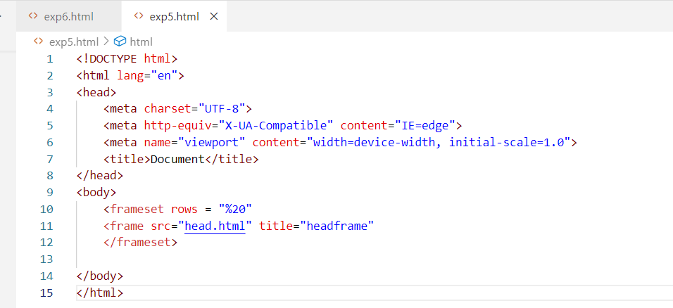

**OUTPUT:**

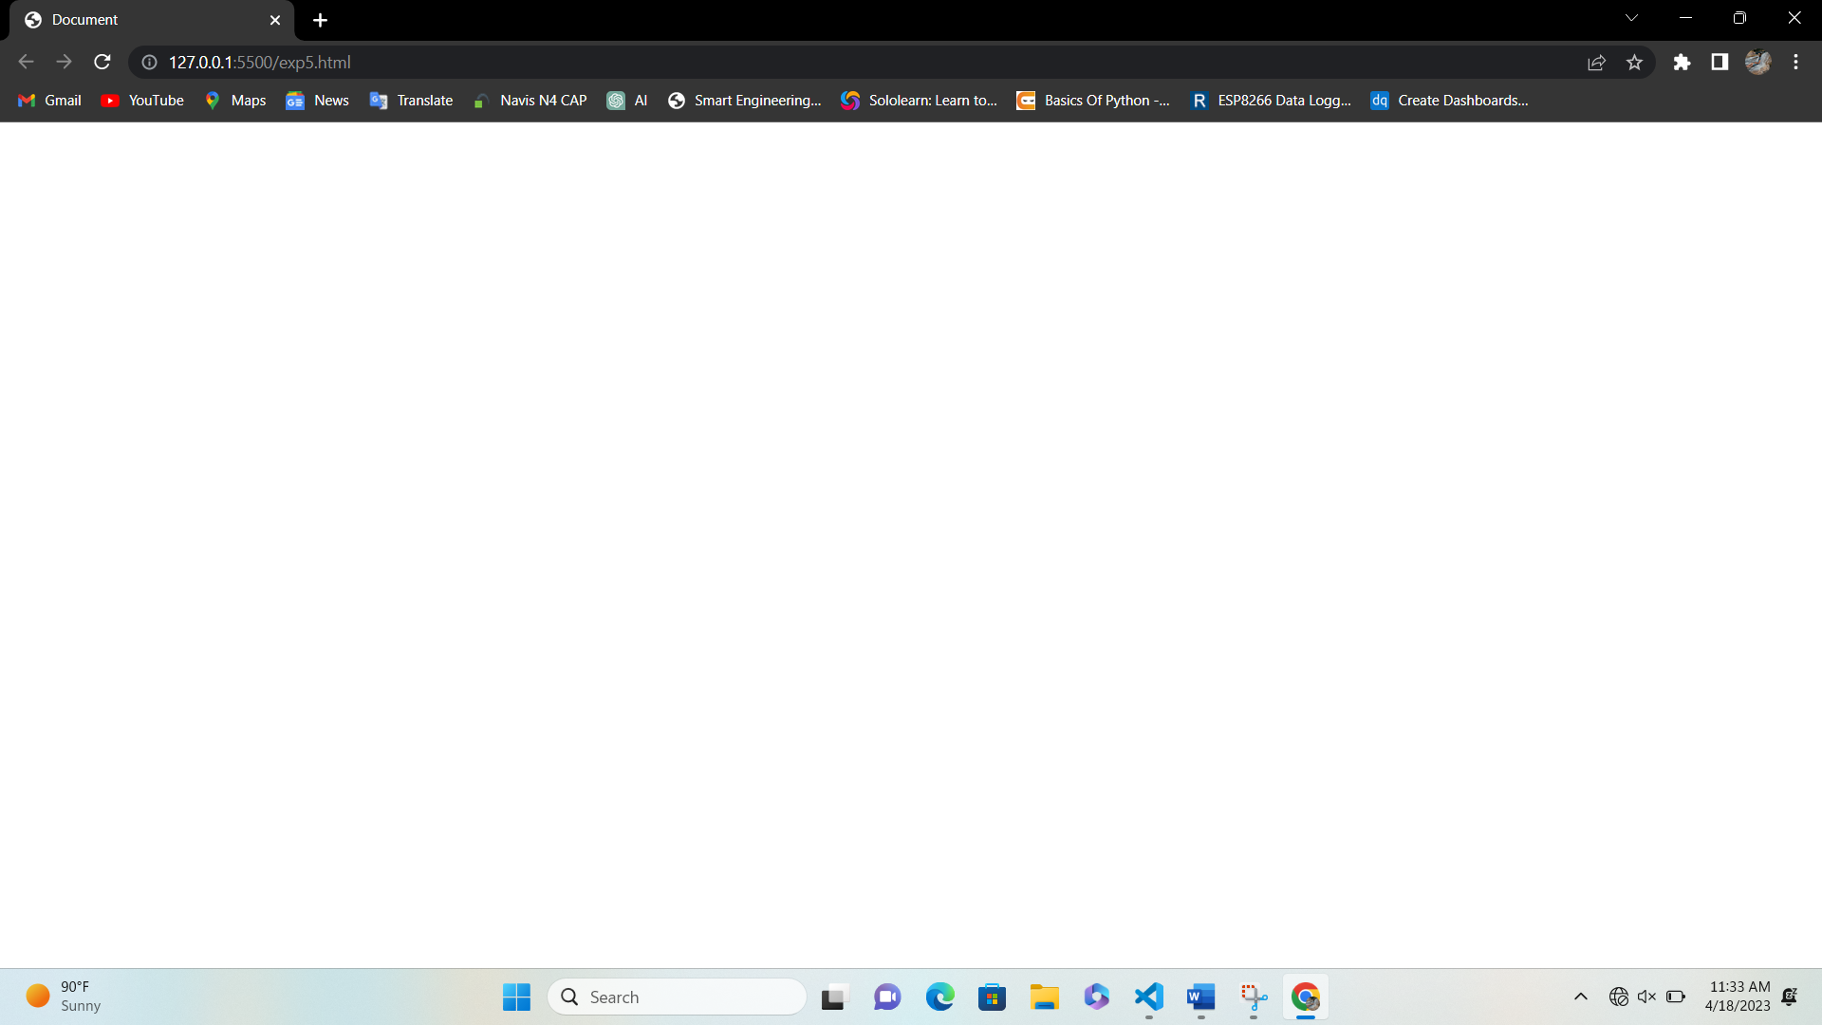

**EXPERIMENT-6**

**AIM:** Write an HTML code to demonstrate the usage of inline CSS Code

**CODE:**

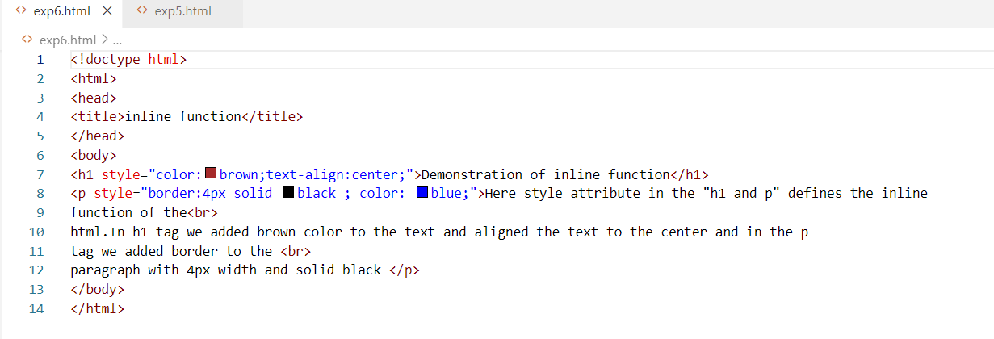

**OUTPUT:**

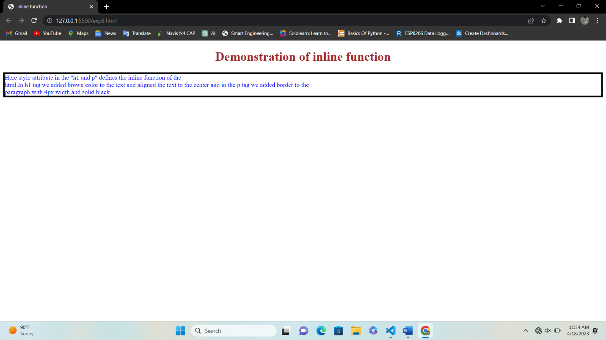

**EXPERIMENT-**7

**AIM:** Write an HTML code to demonstrate the usage of internal CSS Code

**CODE:**

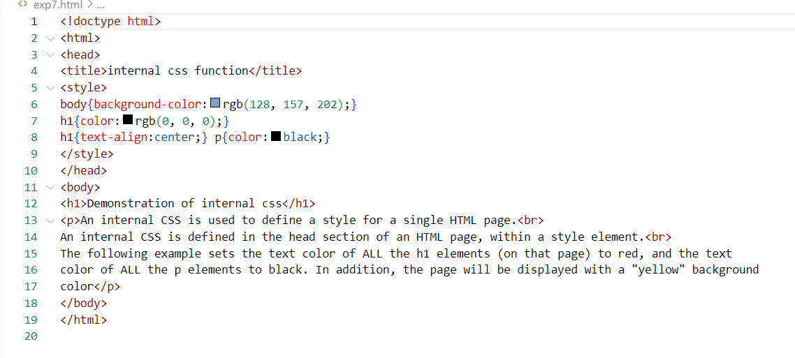

**OUTPUT:**

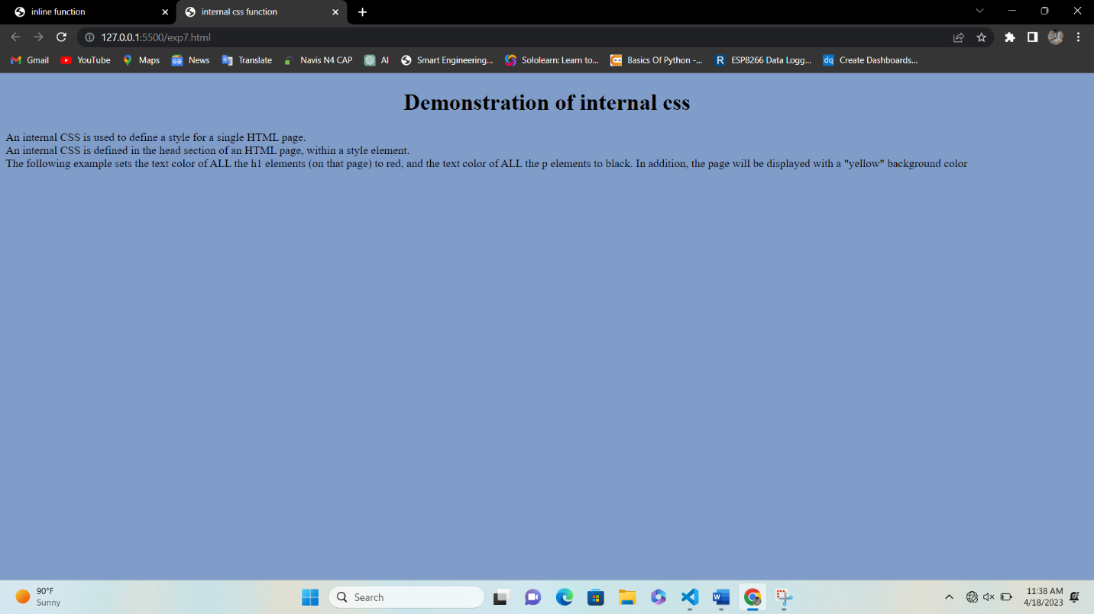

**EXPERIMENT-8**

**AIM:** Write an HTML code to demonstrate the usage of external CSS. Code

**CODE:**

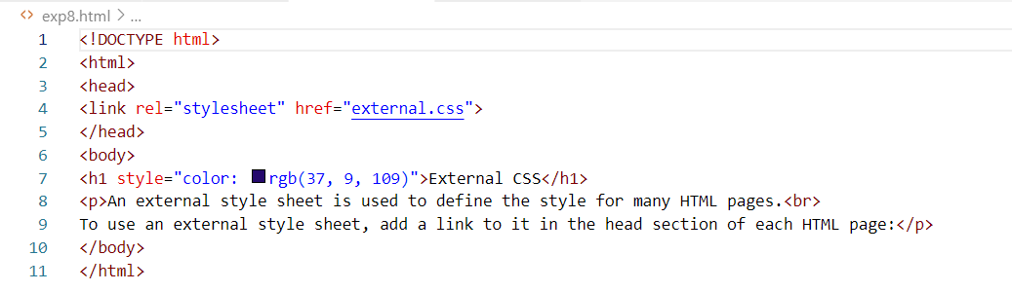

**OUTPUT:**

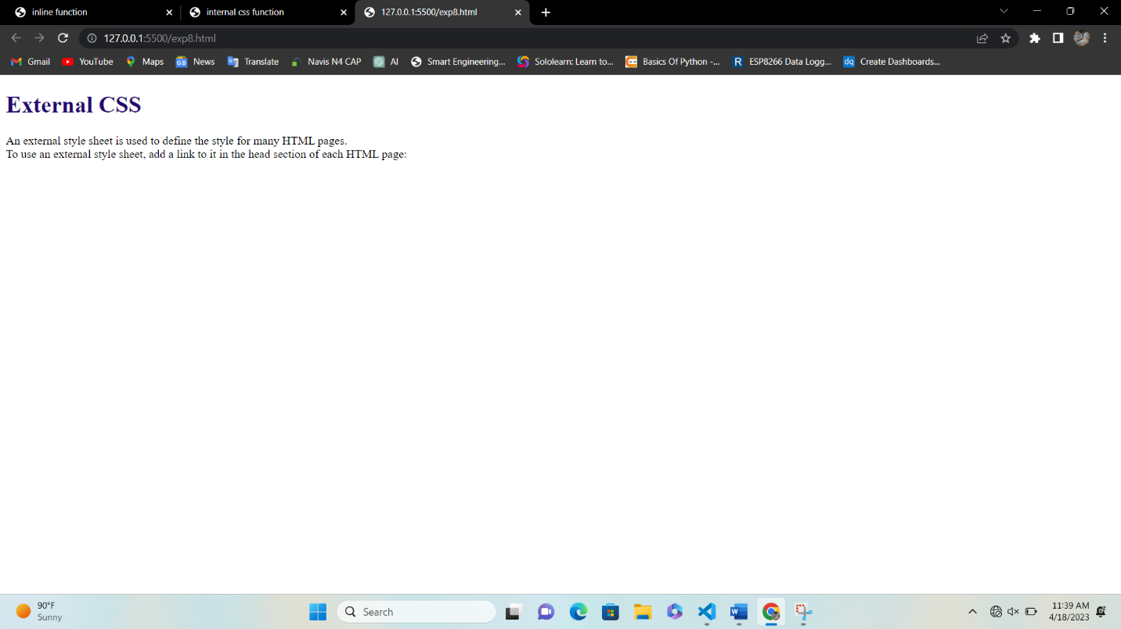

**EXPERIMENT-9 & 10**

**AIM:** Design your own website using HTML CSS

**CODE:**

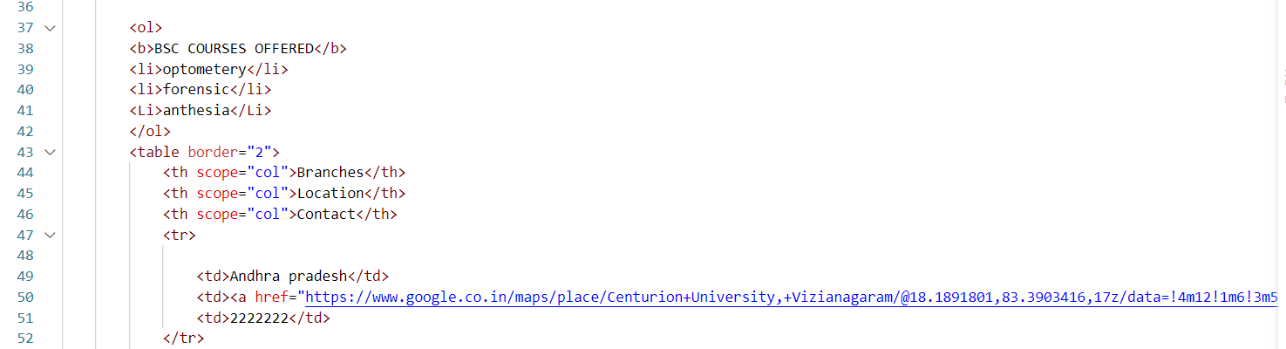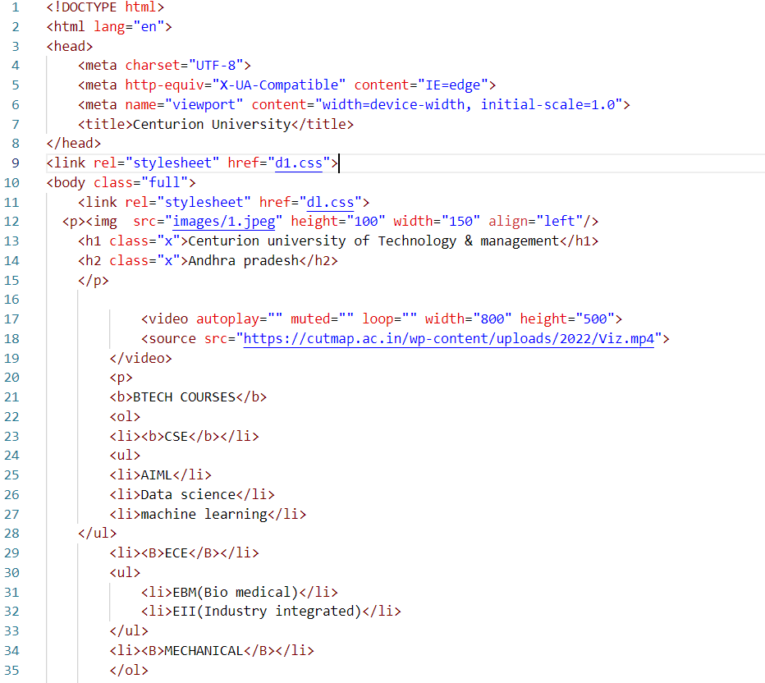

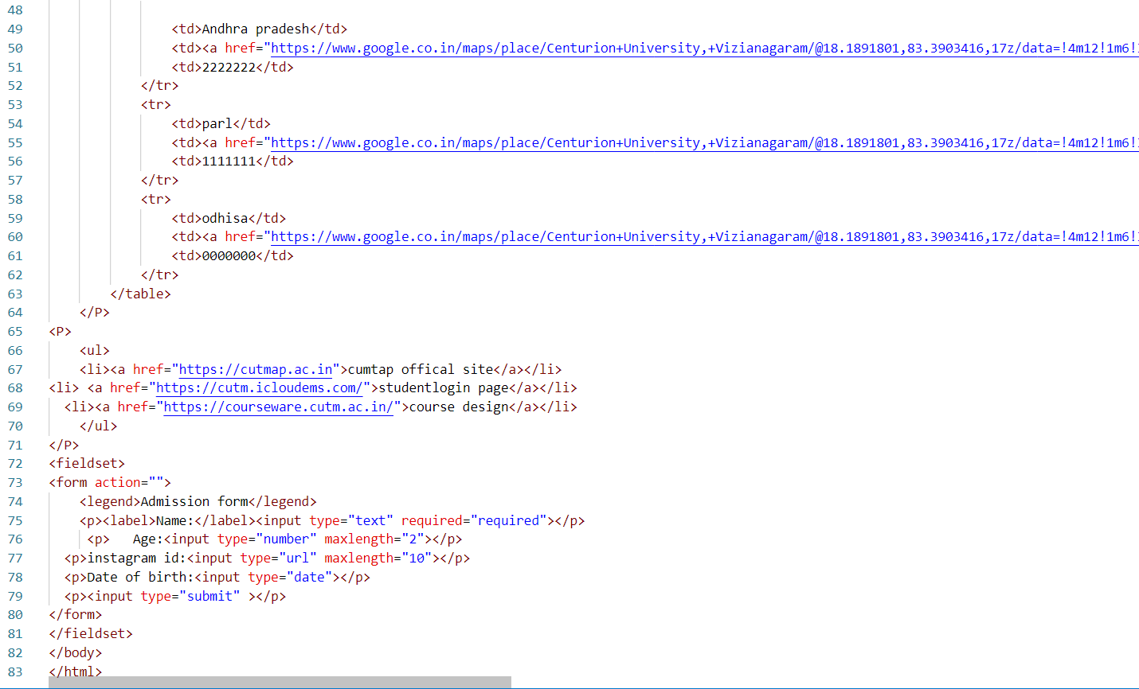

**CSS code:**

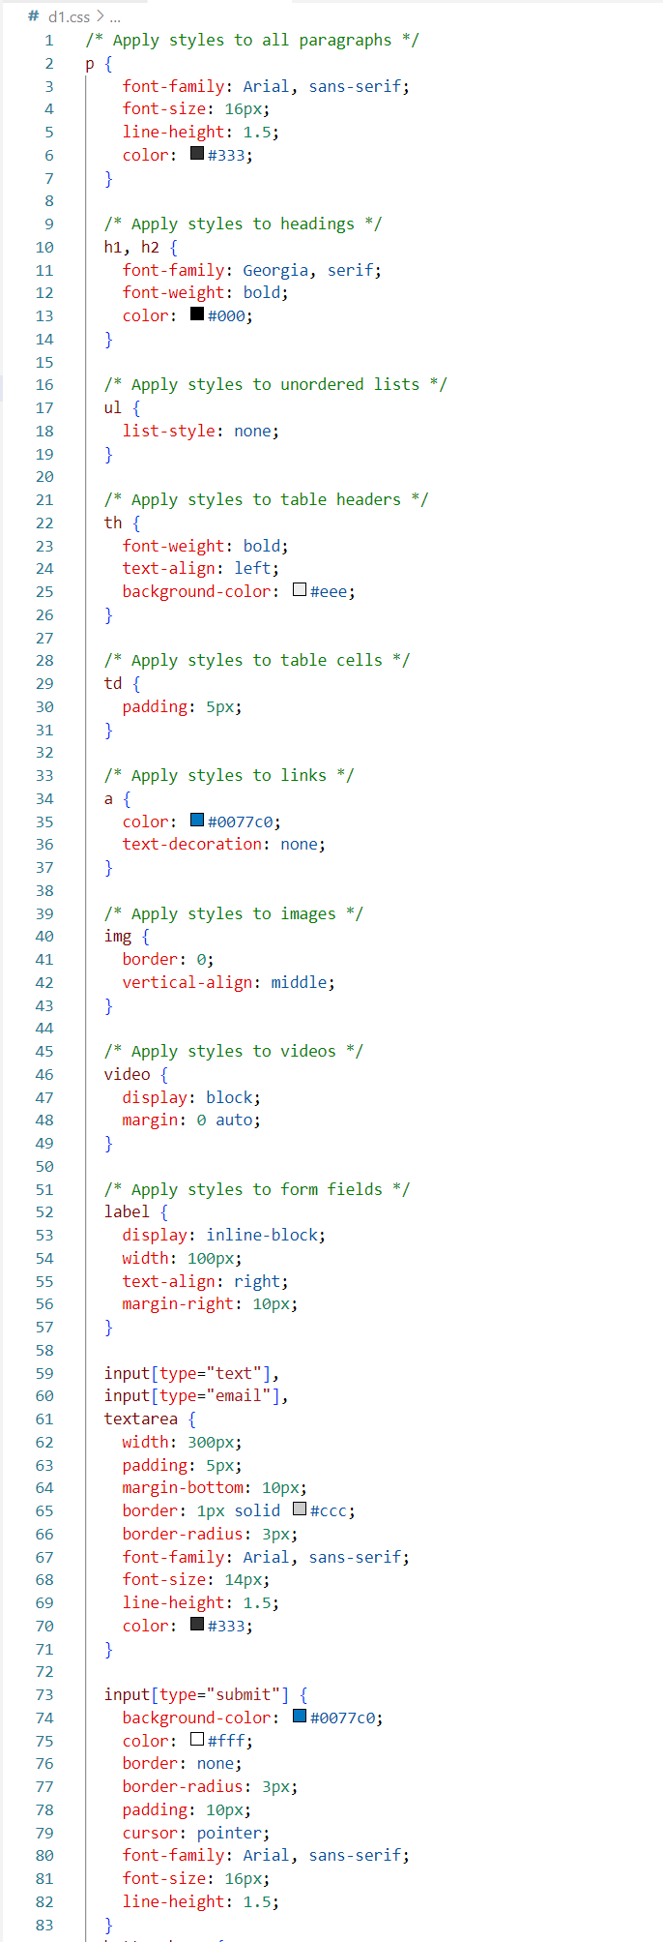

**OUTPUT:**

